Assignment 1
  - Deadline: Day 19/03/2017 @ 23:59
[Total Mark for this Assignment is 8/2=4]

Web Technologies
IT-230

Instructions:
- This Assignment must be submitted on Blackboard via the allocated folder.
- Email submission will not be accepted.
- You are advised to make your work clear and well-presented, marks may be reduced for poor presentation.
- You MUST show all your work.
- Late submission will result in ZERO marks being awarded.
- Identical copy from students or other resources will result in ZERO marks for all involved students.
- Convert this Assignment to PDF just before submission.
Student Details:
Name: Munirah Alrushud  CRN: 21357 |  | ID: 140032004

Question One
1 Marks

Writ the corresponding HTML code that represent the following output list.

- Section1
  - Subsection1.1
    - Subsection1.1.1
  - Subsection1.2
- Section2
Answer:
<html>
<head>
<title> MunirahAlrushud.html </title>
</head>
<body>
<ol>
<li> Section 1 </li>
<ul>
<li> Subsection 1.1 </li>
<ul>
<li> Subsection 1.1.1 </li>
</ul>
<li> Subsection 1.2 </li>
</ul>
<li> Section 2</li>
</ol>
</body>
</html>

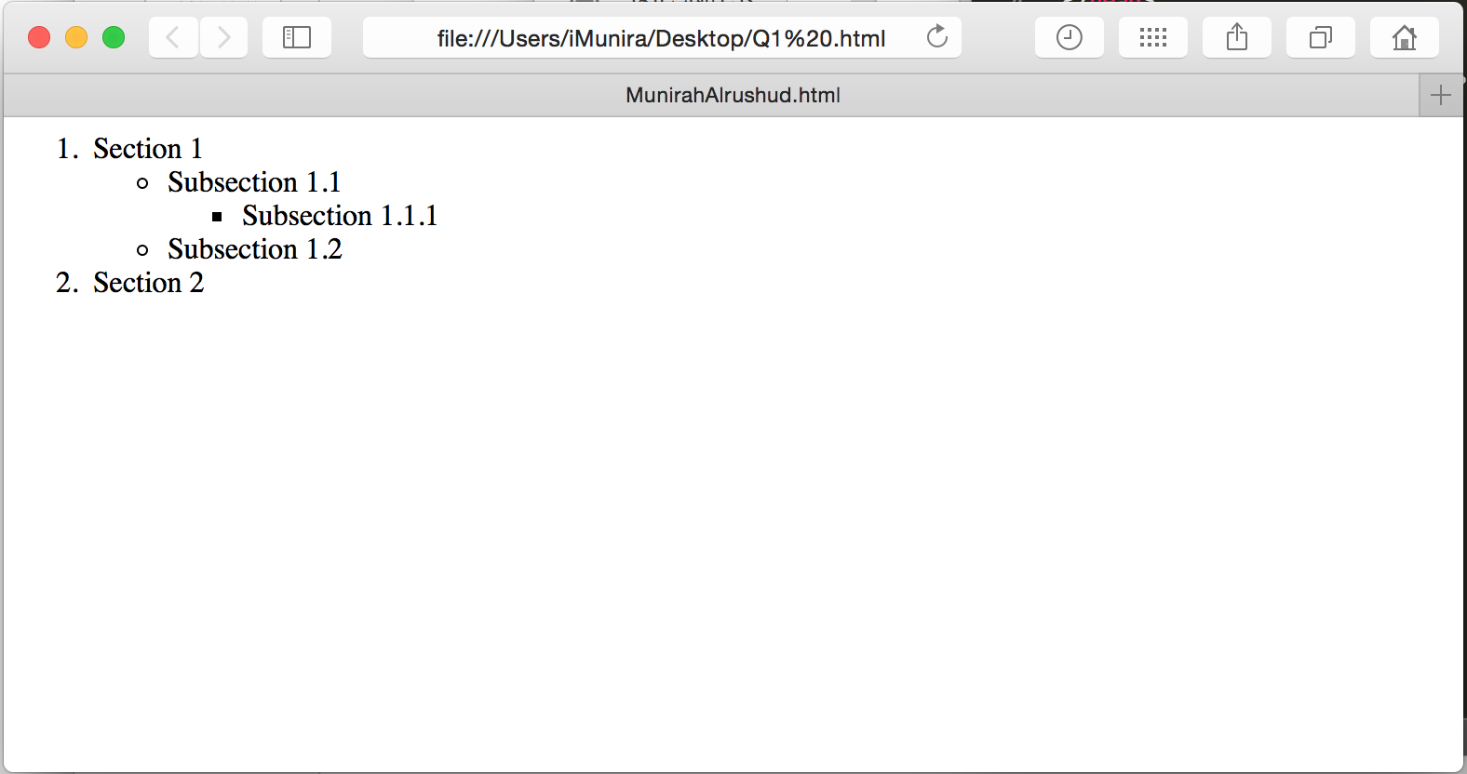

Question Two
2 Marks

Discuss the poor user interface issue in term of embedding images in web page, and what is the appropriate HTML element (including its attributes) that used to embed an image in web page?
Answer:
The poor interface in term of image issues is about not considering many things:
- Not making an alternative (alt) for the picture in case some thing happened to the real picture.
In this case we most use:
<img src="image.png" alt="Not found" height="30" width="80" />
- Not specifying the height and width which will cause some issues because the picture will be uploaded with the original size it will take a lot of space in the web page.
In this case we should use:
<img src="image.png" alt="Not found" height="30" width="80" />
- In some cases, we can specify percentage of client area. By using a string like “20%” or “80%”.
<img ... height="4" width="80%" ... />

Question Three
2 Marks

Write style sheet and HTML programs for the following design
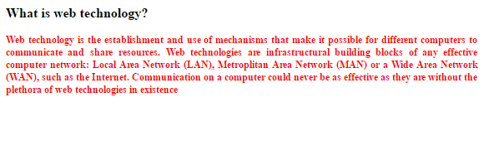

Note: the following conditions should be satisfied
- Content may be anything but it should be like question and answer type.
- Style sheet should be created externally for the following
  - Question font size is 16px, Times New Roman, Justify, bold and font color is black.
  - Answer font size is 12px, Times New Roman, justify and font color is red.
Answer:
.HTML
<!DOCTYPE html>
<html>
<head>
<link rel="stylesheet" type="text/css" href="Q3.css" title="Q3">
<title> MunirahAlrushud.html </title>
</head>
<body>
<P id = Q1 > What is HTML? </P>
<p id = Ans1> HTML is the standard markup language for creating Web page. </p>
</body>
</html>
.CSS
#Q1
{
font-size: 16px;
font-family: "Times New Roman";
text-align: justify;
font-weight: bold;
color: black;
}
#Ans1
{
font-size: 12px;
font-family: "Times New Roman";
text-align: justify;
font-weight: bold;
color: red;
}

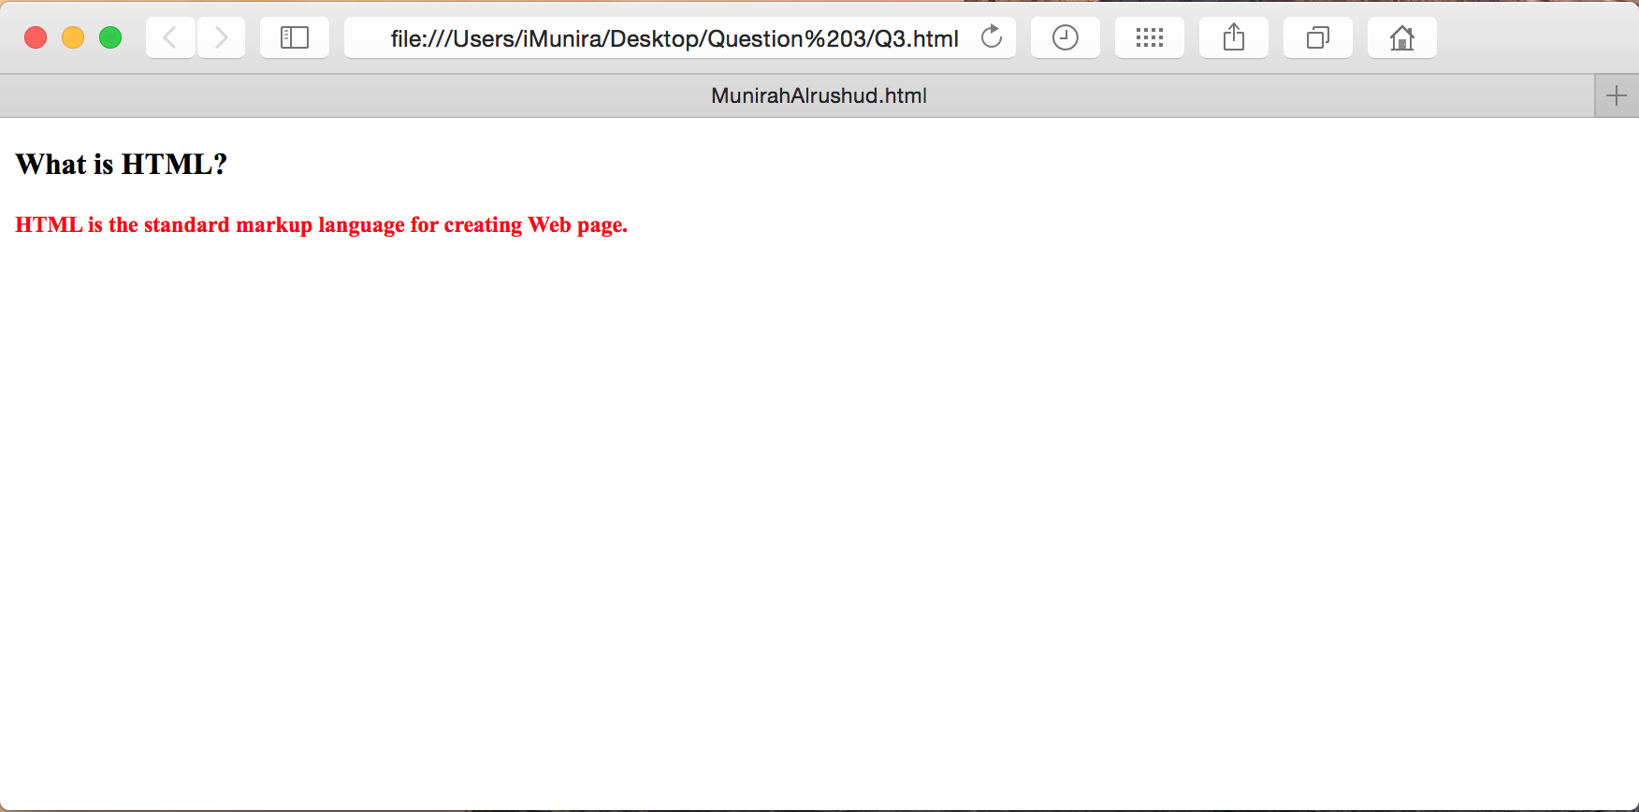

Question Four
2 Marks

Write style sheet and HTML programs for the following design using universal
selector.

Note: the following points should be incorporated,
- Style sheet should be created externally,
- Use Universal selector for the following,
  - Body background color is blue.
  - All text in italic.
- “Hello this is my page” should be bold, center, font size is 30px, Times New Roman and white color.

Answer

.HTML
<!DOCTYPE html>
<html>
<head>
<link rel="stylesheet" type="text/css" href="Q4.css" title="Q4">

<title> MunirahAlrushud.html </title>
</head>
<body>
<h1 id="hello"> Hello this is my page </h1>

</body>
</html>

.CSS
body
{
background-color: blue;
font-style: italic;
}
#hello
{
font-weight: bold;
text-align: center;
font-size: 30px;
font-family: "Times New Roman";
color: white;
}

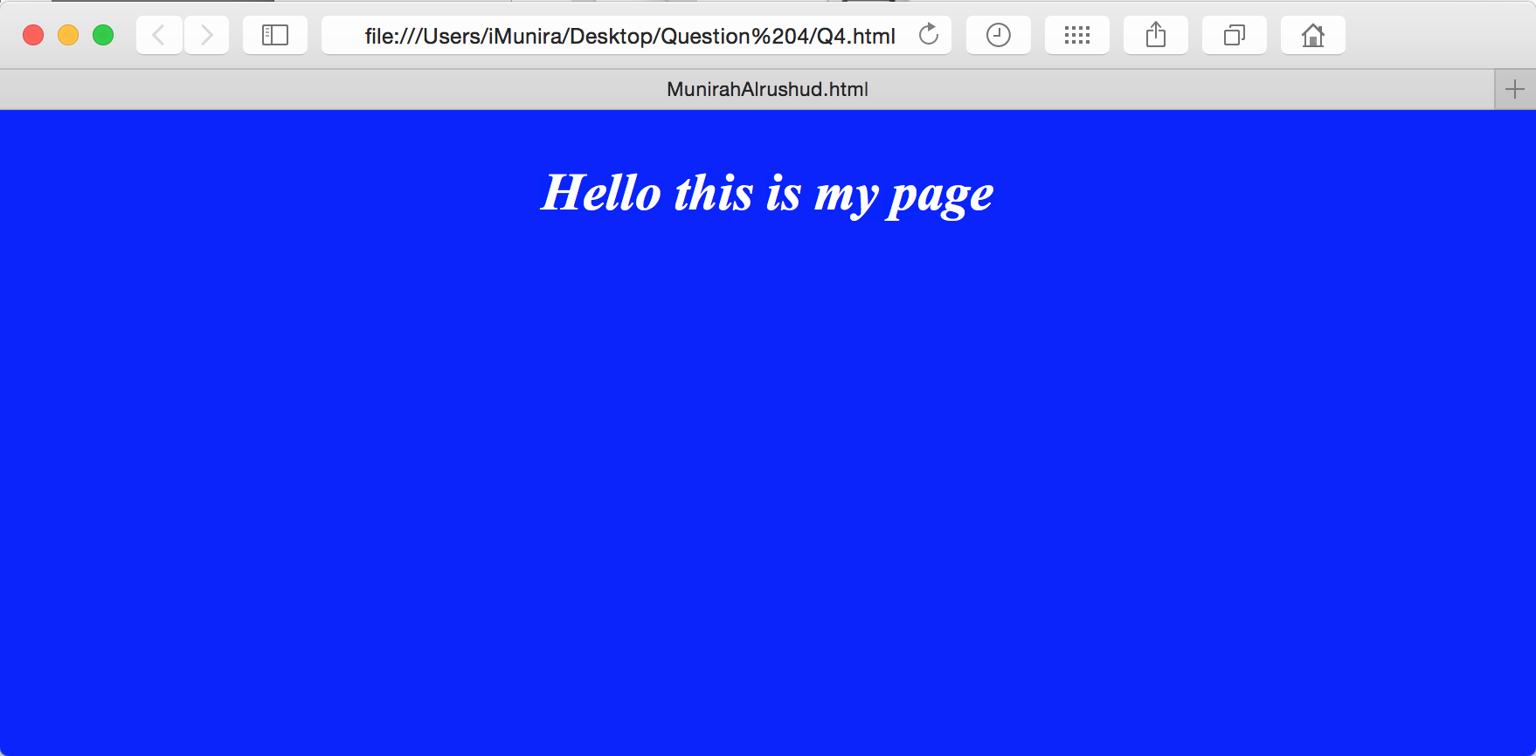

Question Five
1 Marks

What would the browser output ?
<script type = "text/javascript">
<!--
var array = [ [ 1, 2, 3 ], [ 1, 2, 3 ] ];

for ( var i in array )
{
for ( var j in array[ i ] )
document.write( array[ i ][ j ] + " " );

document.writeln("<br />");
}
//-->
</script>

Answer:

123
123

